Life Demo: <http://testdeploy-teamechofyp.rhcloud.com/>

Index page is home.jsp

1. To change pages dynamically, the respective jsp pages are “hooked” into this <div id=”mainContent”> tag inside home.jsp 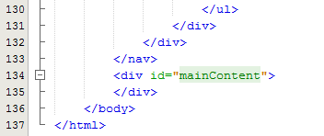
2. This part is the header bar of home.jsp

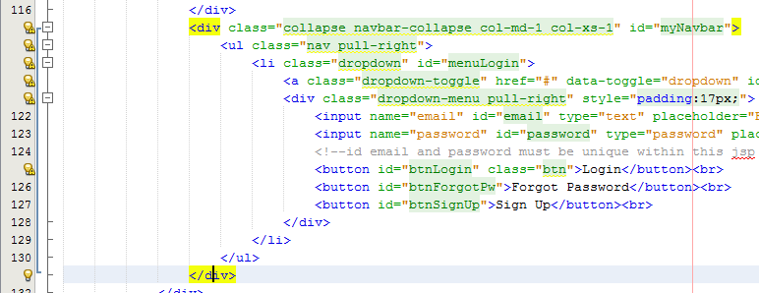

1. As you can see, each <button> tag does the hooking of the respective page. Logic of what to hook in found in the javascript. Notice that identification of <button> is id=””

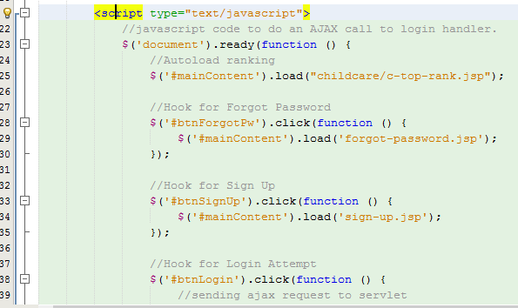  
Notice that the button must be “identified” with the ‘#’ mark. ‘#’ is for unique buttons. Meaning that in the entire home.jsp, there is only one button called #btnForgotPw etc.

1. But for lists of childcares, we also want to hook individual childcare pages over. However if we place the <button> in a for loop, the button won’t be unique anymore. So we have a different calling tag for them.

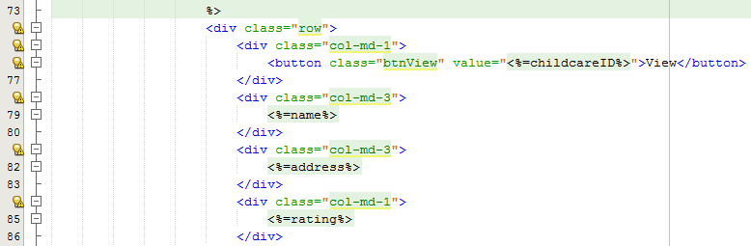  
Here the identification is not “id” but “class”.  
And for the script,  
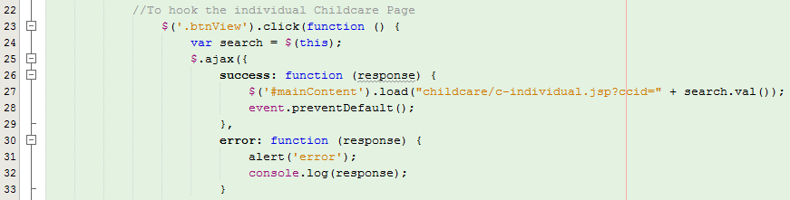  
Instead of “#” have to use “.” This allows us to button different values in the same button with the same name. All these can be found in c-top-rank.jsp

I didn’t explain what info to pass and how to catch the value cause that’s going too in depth already. Roughly this is how the gist of the dynamic hooking works. I wasn’t the one who found and implemented this framework, it was our previous Front End Designer who found it and so far Daniel and I found that it’s not browser friendly. But I suspect that all the problem lies in the header and not the script logic.